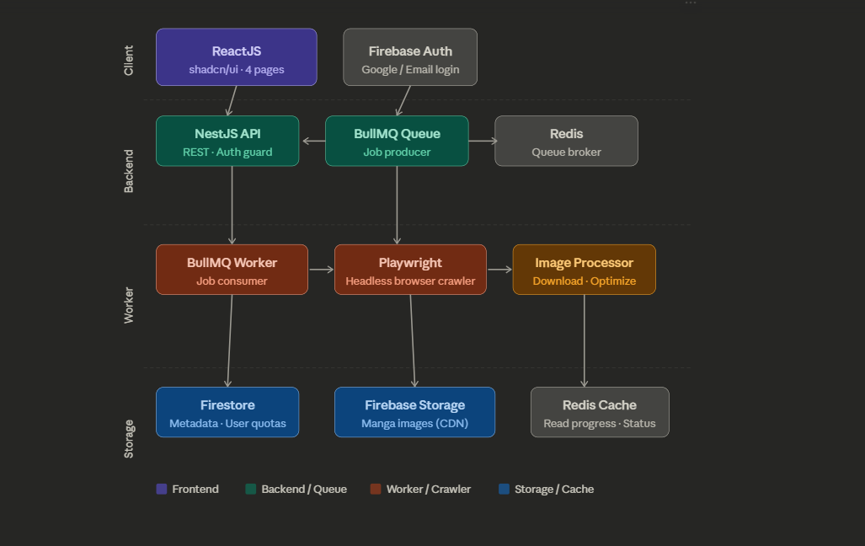

🎓 Document 4 — Learning Resources (theo thứ tự học)
Bước 1 — NestJS (Backend foundation)
- 🔗 NestJS Official Docs — First Steps
- Keywords: Module, Controller, Service, Dependency Injection, Guards, Interceptors
Bước 2 — BullMQ (Queue)
- 🔗 BullMQ Docs
- Keywords: Queue, Worker, Job, Concurrency, Job lifecycle (waiting → active → completed/failed)
Bước 3 — Playwright (Crawler)
- 🔗 Playwright Docs
- Keywords: page.goto(), page.waitForSelector(), page.$$eval(), stealth mode
Bước 4 — Firebase (Auth + Storage + Firestore)
- 🔗 Firebase Web SDK Docs
- Keywords: onAuthStateChanged, Firestore rules, Storage upload, Security rules
Bước 5 — React + shadcn/ui
- 🔗 shadcn/ui
- Keywords: useQuery, useMutation, React Query, Optimistic updates

